Lets make the speed increase for 3 seconds when we press the space bar.

1)First we want to create a speed variable

**Arrange the following pieces of code together.**

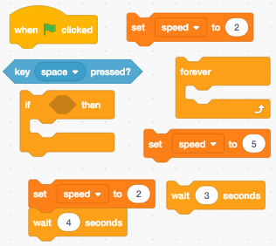

Lets make the speed increase for 3 seconds when we press the space bar.

1)First we want to create a speed variable

**Arrange the following pieces of code together.**



Lets make the speed increase for 3 seconds when we press the space bar.

1)First we want to create a speed variable

**Arrange the following pieces of code together.**



Lets make the speed increase for 3 seconds when we press the space bar.

1)First we want to create a speed variable

**Arrange the following pieces of code together.**



What happens when the mouse hits the other player’s laser?

2)We must detect when it hits the other player’s color.

3)Then broadcast that the player lost so the other player’s score gains 10 points

4) Lastly broadcast “start” to restart the game.

**Arrange the following pieces of code together.**

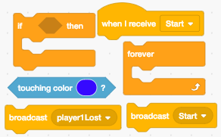

What happens when the mouse hits the other player’s laser?

2)We must detect when it hits the other player’s color.

3)Then broadcast that the player lost so the other player’s score gains 10 points

4) Lastly broadcast “start” to restart the game.

**Arrange the following pieces of code together.**



When the mouse hits the edge, it must teleport to the opposite side and keep on going.

5)We must detect when it touches the edge on the left and right side. We do this by having three conditions.

6)Once edges are detected, lift up the pen, set the mouse to the opposite of the screen and place the pen down.

7)Look at picture below to see how to code the left and right side of the screen.

8)Then try to put the pieces of code together to code the bottom and top side of the screen.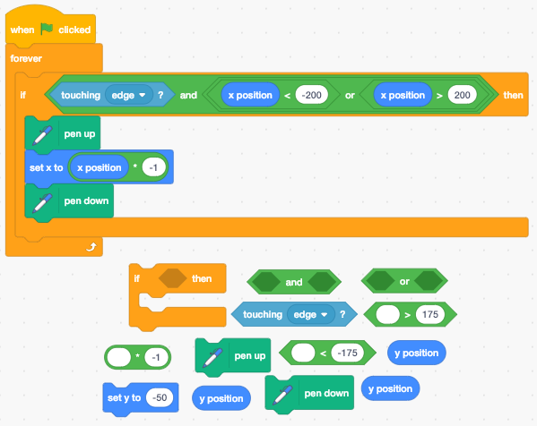

When the mouse hits the edge, it must teleport to the opposite side and keep on going.

5)We must detect when it touches the edge on the left and right side. We do this by having three conditions.

6)Once edges are detected, lift up the pen, set the mouse to the opposite of the screen and place the pen down.

7)Look at picture below to see how to code the left and right side of the screen.

8)Then try to put the pieces of code together to code the bottom and top side of the screen.